YOUNG ARTIST’S WORKSHOP Fall 2016

Do you love art? Are you between the ages of 5-18? Sign up for the YOUNG ARTISTS WORKSHOP today!
The following classes will be offered during the fall semester:

Ages 5-7: Drawing, Painting & More
Ages 8-9: Drawing, Painting & More
Ages 10-12: Drawing, Painting & Mixed Media
Ages 13-18: Drawing, Painting & Printmaking

Where: McMaster Building, USC Campus
When: Fridays from September 23rd through Friday November 11
Cost: $70.00 per student
$60.00 per student (if parent is USC faculty, staff, or student)

***IN ORDER TO RECEIVE THE DISCOUNT RATE, YOU MUST PROVIDE A PHOTOCOPY OF YOUR USC IDENTIFICATION CARD AT THE TIME OF PAYMENT.
For more information call: Allison Dunavant, YAW Coordinator: yaw.usc@gmail.com
Application Deadline: Wednesday, September 21, 2016

Application Form
Name of child: Age: _____
Age:
Age:
Name of parent or guardian:
Address:

Home Telephone Number:
Work Telephone Number:
E-mail Address:_____________________________________________

Ages 5-7: __________Drawing, Painting & More
Ages 8-9: __________Drawing, Painting & More
Ages 10-12: ________Drawing, Painting & Mixed Media
Ages 13-18: ________Drawing, Painting & Printmaking

Enclosed Fee:
If affiliated with USC, please check one of the following: ___Faculty ___Staff ___Student

Medical Information

Tetanus shot: ___Yes ___No Effective Date:
In case of emergency, notify:
1. Name: Telephone number:
2. Name: Telephone number:
Family Doctor/Pediatrician: Telephone number:

Mail application to: YOUNG ARTISTS WORKSHOP
Attention: Allison Dunavant
School of Visual Art and Design
University of South Carolina
Columbia, SC 29208

Please make checks payable to: USC Art Fund, THERE WILL BE NO REFUNDS.
yaw.usc@gmail.com

All fees are due before Friday, September 23, 2016

Please write your email address below if you would like to be added to our list to receive updates and reminders about the Young Artist’s Workshop program.

Email Address:_______________________________________

YOUNG ARTIST’S WORKSHOP DATES

Fall 2016

Fridays, 4:00 p.m. – 5:30 p.m.

September 23rd - First YAW

September 30th - Second YAW

October 7th - Third YAW

October 21st - Fourth YAW

October 28th - Fifth YAW

November 4th - Sixth YAW

November 11th - Exhibition/Reception

MAP:

Students attending the Young Artists Workshop should be brought to the front entrance of the McMaster College of Art (Pickens St. side, yellow dot on map), on the USC campus between 3:45 and 4:00 pm. Metered parking is available along Senate and Pickens Streets. Students will be greeted by their instructor on the second floor of McMaster and escorted to their classes. If you should arrive after 4:00 pm, with your child’s safety in mind, please escort your child to their classroom. Please remind your Young Artist to Dress for Mess! Student’s ages 5- 9 will be dismissed from their classrooms each Friday. Parents must pick them up from the classroom. All other students will be escorted to the front entrance of McMaster College at 5:30 p.m. to await your arrival.

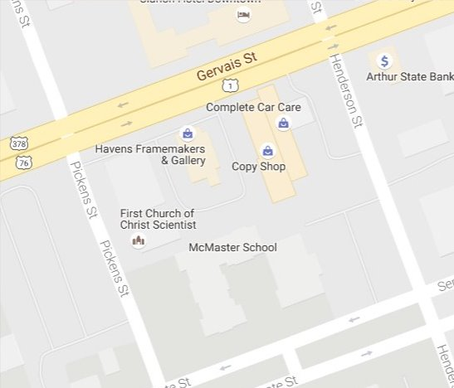

Permission/Release Form

I hereby certify that I am the parent or guardian of ___________________, and give Dr. Minuette Floyd, Professor of Art Education at the University of South Carolina, the right and permission to publish in print or electronically photographs of my child and/or artwork taken during the Young Artist workshop at the University of South Carolina, as well as writings and artwork by the student named above. Your child’s art work and / or photographs of your child may be used on the USC webpage (YAW link) and for educational purposes only.

I understand that the student will be identified by his or her first name only.

Parent Signature: _________________________________

Date:_____________________

To be completed by the YAW coordinator

Class: _________________________________________________

Age:________________________________________________

